Profile  Branden Gardner  Results-oriented IT Specialist with proven leadership skills. Over 5 years of experience as an IT professional. Aiming to pivot my career and leverage my skills as a versatile Data Scientist and Engineer.  Contact  PHONE:(404)644-1733  LINKEDIN:  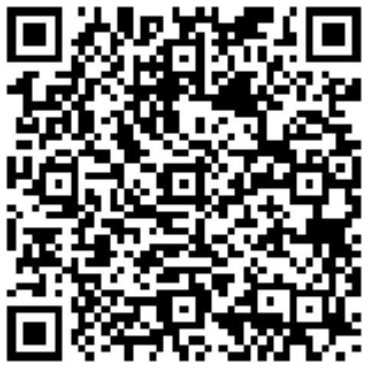  https://www.linkedin.com/in/branden-gardner-827062ba/  EMAIL  Bigardner04@gmail.com  Skills  SQL  Python  Office Suite  Server Management (Virtual/Physical)  Cloud computing (Azure)  Data Visualization  Interpersonal Skills  HTML  Firewall maintenance.  CMD/Scripts  Math Statistics Courses  CERTIFICATIONS  [DP-100] Azure Data Scientist Associate  [PCEP-30-02] Certified Entry- Level Python Programmer  [AZ-900] Azure fundamentals  [PCAP] Certified Associate- Level Python Programmer (in progress) |  | WORK EXPERIENCE  System Administrator  Onepath LLC.  2019-present  Managed IT for various companies. Performed various troubleshooting for clients  - Creation of Power BI models that provided insights into the organization’s performance metrics.  - Mass Integration of clients for Azure  - Creation and management of remote environments (RDP,WVD, & VMWare))  - Provided seamless customer service for all clients in all technical aspect.  - Resolved technical issues for clients using a queue/ticketing system (ATLAS), tickets created either by phone or email.  - Maintained network and server integrity of all clients.  - Hosted email servers and maintain client's structural integrity  - Performed various of troubleshooting (printers, cell and desktop phones, scanners  - Explain technical issues in clear and concise way that the client can understand.  - Perform quarterly preventative maintenance assessments on client servers  - Physical setting up of computers and software system installation for various computer applications and programs-Install software  - Script creation for streamlining processes.  ITT Specialist  Georgia State University  2015-2019  - Perform technology services for students., execution and implementation of removing malware/viruses and installing protective software  - Develop processes and tools at a basic level to provide greater quality and consistency when helping students or professors  - Interact with teams and leaders to identify and implement standards for providing a better service for the campus technology wise  - Fix technological issues when a professor is having trouble, or not used to, operating the systems in place  - Produce daily, weekly, monthly program status reports to ITT Leadership  - Monthly meetings with leaders to ensure adherence with technology and training for new employees.  EDUCATION  Georgia State University  2014-2019  Bachelor of Managerial Science -BAS, IT Management

